GARDENCITY UNIVERSITY
ADVANCE JAVA

NAME – UJALA YADAV
SEM – 5TH, SEC – A
ROLL NO- 24BTCE147

PROGRAMS-
1. Write a Java program to demonstrate the concept of classes and objects. Create a class named Student with data members such as student name and student age. Create an object of the class and display the student details using a method.
Ans -
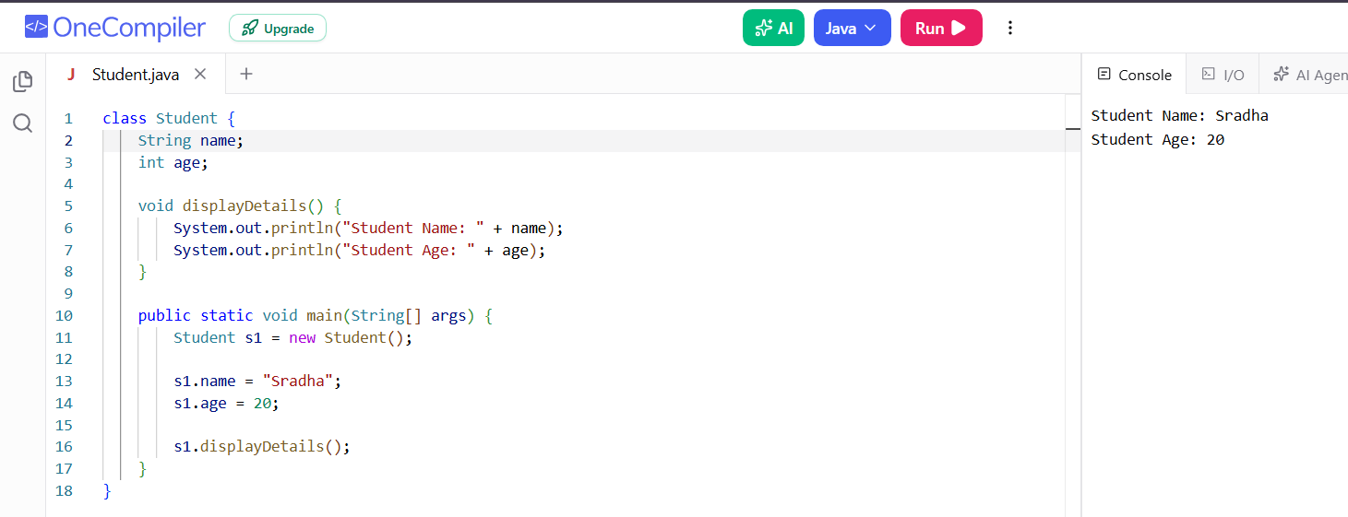

2. Write a Java program to demonstrate the concepts of inheritance and polymorphism. Create a parent class named Animal and a child class named Dog. Use method overriding to achieve runtime polymorphism and display the behavior of both classes.
Ans –
